DATABASE SYSTEMS ENGINEERING AND DISTRIBUTED BACKEND DEVELOPMENT

TOPIC: AGGREGATE FUNCTIONS with WHERE, GROUP BY,
HAVING, ORDER BY

2520030371 – P. HAVISHAA REDDY
STEP 1: CREATE TABLE:

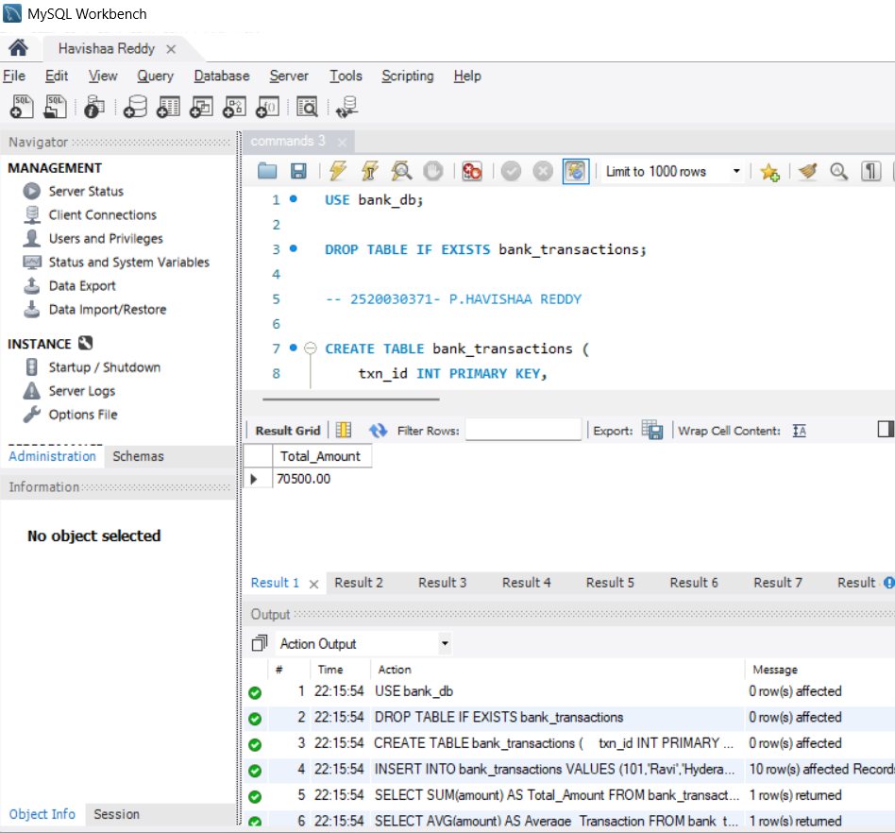

QUESTION 1 - SUM():

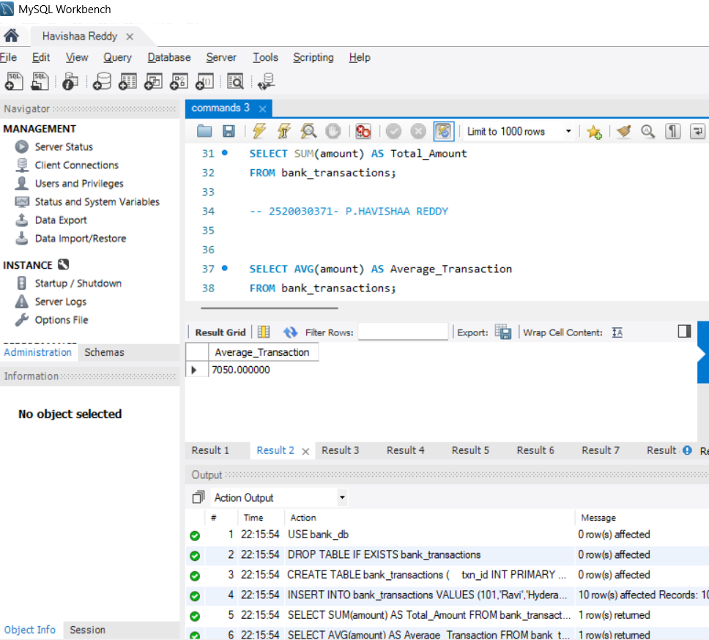

QUESTION 2 - AVG():

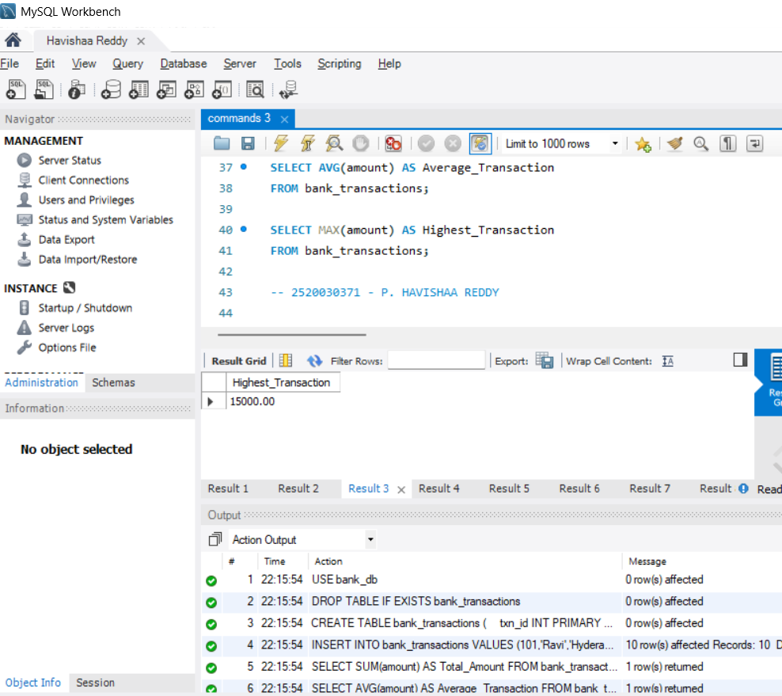

QUESTION 3 - MAX()

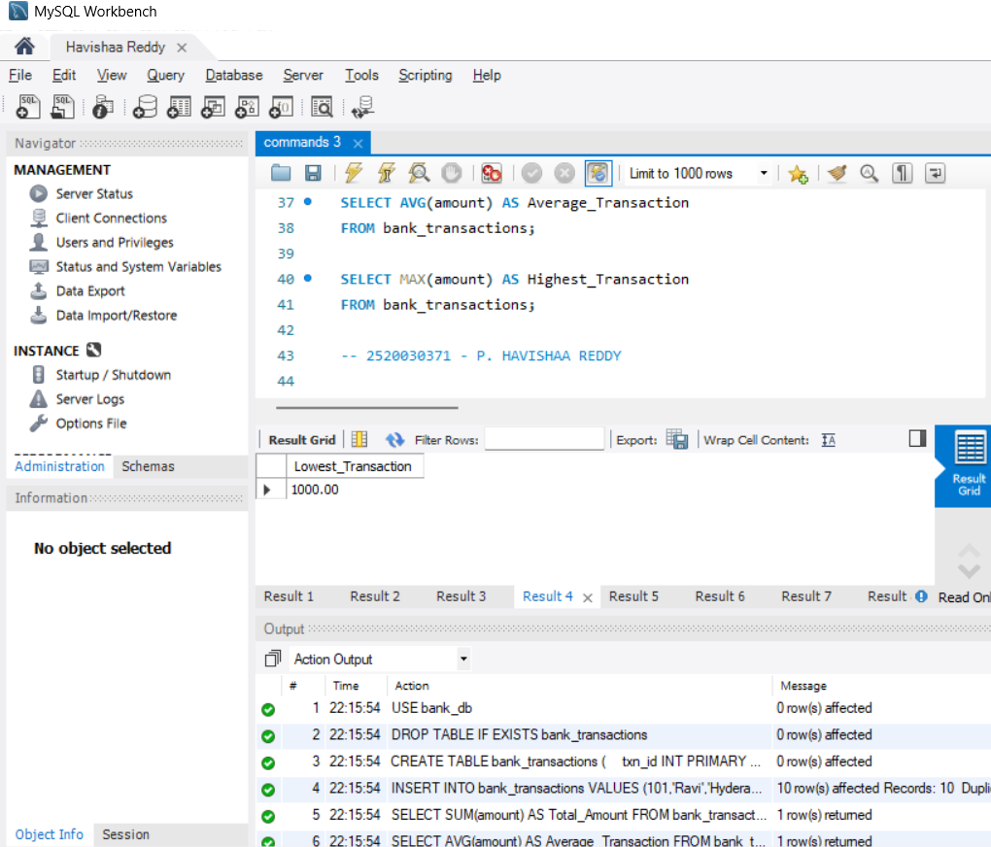

QUESTION 4 - MIN()

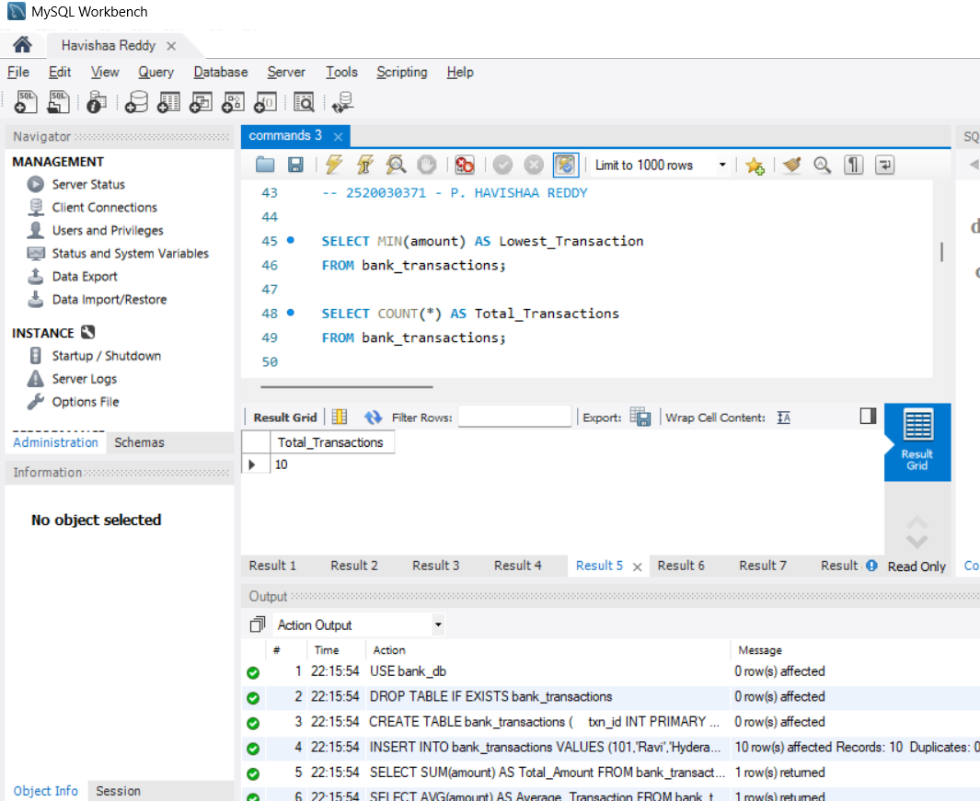

QUESTION 5 - COUNT()

